Scottish Highlands & Islands Tour
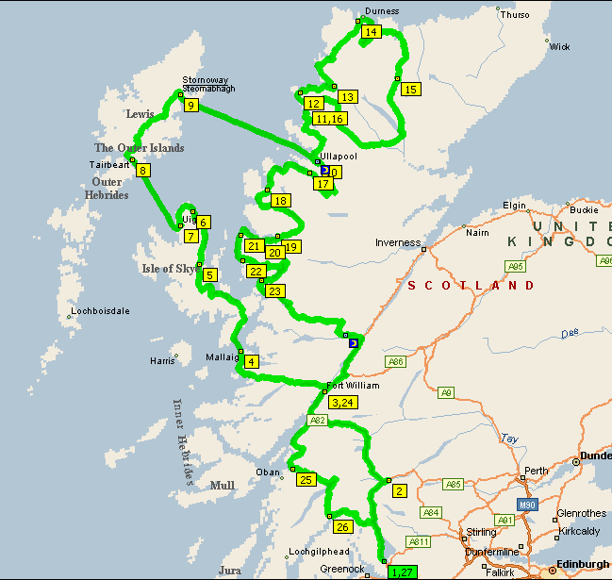
15-26 May 2011

www.classictravelling.com/xk-scotland

